Floor Plan Reconfiguration

Pre-Rehab:
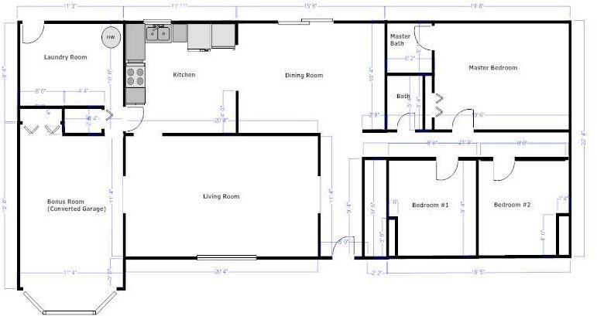

Post-Rehab:
