Sample Business, LLC

Sample Business Plan
February 6, 2011

Investor Contact
Your Name
Phone: xxx-xxx-xxxx
email@youremail.com

Table of Contents

Executive Summary 3
Introduction 3
Management and Team 3
Business Structure 3
Corporate Goals 4
Project Goals 4
Financial Goals 4
Personnel Goals 4
Corporate Strategies 5
Acquisition Strategies 5
Rehabilitation Strategy 6
Exit Strategy 7
Market Trends 8
Sales & Marketing Strategy 11
Sales Strategy 11
Marketing Strategy 11
Staging 12
Equity & Financing Strategy 13
Equity Strategy 13
Financing Strategy 14
Investment Strategy 15
Property Analysis Techniques 15
Rehab and Resale Example 15
Long-Term Hold Example 16
Financial Plan 18
Initial Investment 18
1-Year Acquisition Plan 18
5-Year Acquisition Plan 18

Executive Summary

Introduction
Sample Business is an Atlanta-based real estate investment company initially formed in January 2008. The company is operated out of its home-office in Mableton, GA, and is fully owned and controlled by Business Owner, a full-time resident of Georgia.
The company intends to purchase distressed single-family residential property in Cobb County, GA for the purpose of rehabbing and reselling for profit to other investors and to owner occupants. Target properties will include REO foreclosures, pre-foreclosures and potential short-sales all selling for well-below market value.

Management and Team
The day-to-day operations of the company will be actively managed by Business Owner, with additional full-time staffing to be considered once the company has consistent and adequate cash flow, or when additional outside investment is available. Business Owner has 5 years of real estate investing experience and 10 years of corporate management experience, both of which will contribute to the long-term success of Sample Business.
The company will handle all aspects of property acquisition, property renovation, and property disposition. Additionally, the company will assemble a strong team of investment advisors, industry professionals and licensed contractors to ensure its investment plan is well-defined and successfully executed. This includes finding a qualified CPA, real estate attorney, and title attorney, as well as assembling a team of real estate agents, inspectors, appraisers, insurance agents, etc.

Business Structure
The company will retain the services of both an experienced real-estate attorney and a qualified CPA; based on their recommendations, is it expected that Sample Business will be formally structured as a limited liability company (LLC), and taxed as an S-Corporation. Additionally, it is expected that the company will hold each of its investment properties as a separate limited liability corporate entity (LLC).
The purpose of this corporate structure will be two-fold:
- Provide asset protection and shield individual assets from any liability created by other assets;
- Provide sound and strategic tax benefits to the company and its owners/investors.

Corporate Goals

Project Goals
The company plans to purchase, rehab and resell-for-profit a minimum of 4 properties in its first year. With the experience gained in year one, the company expects to acquire and resell a minimum of 6 properties in year two, and will continue to grow by at least 2 properties per year moving forward.
As our experience grows, we expect to progressively move from lower-priced properties to higher-priced properties, where the profit margins will increase, allowing us to generate more income from the same number of projects.

Financial Goals
In year one, the profit on each project is expected to average $15,000. In year two, as the company shifts towards tackling higher-end projects, we expect the average profit-per-project to increase to $20,000. In subsequent years, the projected profit-per-project should continue to rise, with the goal to increase average profits at least $5,000 per year.
Given these project and financial goals, the income forecast for the first five years of business is expected to look as follows:

Year | # of Projects | Average Profit | Total Annual Profit
1 | 4 | $15,000 | $60,000
2 | 6 | $20,000 | $120,000
3 | 8 | $25,000 | $200,000
4 | 10 | $30,000 | $300,000
5 | 12 | $35,000 | $420,000

Personnel Goals
In year one, Business Owner will be managing all business operations. In year two, the company will likely hire one full-time employee to assist in managing various aspects of the business. The company will re-evaluate the need for additional personnel as necessary.

Corporate Strategies
The company will utilize an array of strategies to achieve both its short- and long-term financial goals. This includes a variety of property acquisition strategies, a variety of renovation strategies and a variety of disposition/selling strategies, all dependent on the specific target property.

Acquisition Strategies
The company intends to purchase distressed properties at or below 50% of fair market value. By purchasing properties at this far below market value, generating consistent and substantial profits will be achievable. Leveraging the depressed local real estate market, the company will focus on acquiring distressed single family homes using a variety of means:
- Foreclosure Auctions: In Cobb County, GA alone, there are now over 1000 foreclosed properties per month being auctions on the court-house steps. With the number foreclosures continuing to rise in the county, the number of auctioned properties will also continue to rise. With proper due diligence and investigation, purchasing foreclosed property at auction is an excellent way to acquire property at far below market value.
- Bank REO: With the skyrocketing number of foreclosures in the Atlanta area, banks are starting to get aggressive in their attempts to move bank-owned (REO) real estate inventory. In many cases, banks are willing to sell inventory at a substantial discount to market value, especially for serious buyers who have the ability to close multiple deals and close quickly. The company is already in the process of networking and forming relationships with various real agents who represent banks in marketing and selling REO property.
- Local Marketing: By using inexpensive local marketing techniques, the company hopes to bring distressed property owners forward to generate lead. This includes advertising with “bandit signs,” putting ads on Craigslist, and working with local “We Buy Houses” firms to generate leads on prospective sellers.
- Neighborhood “Farming”: Still one of the most effective ways to locate and acquire investment real estate is to spend time learning a specific area inside and out. This includes driving around the area, speaking with local real estate agents, speaking with local property owners, and inquiring about available real estate marked as for sale or for rent. It is expected that the company will focus its attention on a small number of local areas to get familiar with real estate value and trends in those specific areas.

- Internet Research: In recent years, the Internet has become an invaluable tool for locating and evaluating potential investment real estate. Not only can much of the MLS inventory be found online, but sites such as “Craigslist.org,” “ForSaleByOwner.com,” “FSBO.com” and many others are used to list property for sale by owner. With years of experience in the technology industry, Business Owner will be able to leverage the Internet to find and acquire local properties at substantial discounts.

Rehabilitation Strategy
Because it is likely that a high percentage of properties that the company acquires will require some degree of rehabilitation prior to resale, the company will have to build a core competency in evaluating the condition of a purchased home and improving it appropriately. The level of rehab work for each property will be highly dependent on the expected exit strategy for the property, ranging from minor cosmetic improvements to major structural overhaul and remodeling.
The company will utilize the following resources to ensure that all renovation is evaluated and completed appropriately, on-budget, and on-schedule:
- Inspections: All properties will have a thorough pre-purchase inspection by a licensed inspector. Inspections will provide a comprehensive checklist of property defects to be repaired during the renovation process. The cost of a full pre-purchase inspection will be factored into each project, as part of the renovation costs.
- Budget Estimation: The company will work with a licensed General Contractor (GC) to review the Inspection Checklist provided by the property inspector; based on the Inspection Checklist, the GC will provide a total rehab budget estimate that will be used to analyze the viability of the project.
- Renovation Management: Each rehab will be managed and overseen either by the GC or by Business Owner. For substantial renovation efforts that require permits and structural redesign, the GC will be hired to manage all aspects of the project, as well as to provide the sub-contractors necessary to complete the project. For smaller renovation projects, Business Owner will hire, manage, and oversee the individual sub-contractors necessary to complete the project.
Performing on-budget and on-schedule rehab will be a large component of the company’s success, and as such, it will implement processes, procedures, and controls that will allow it to continually improve its ability to estimate and execute on property rehab.

Exit Strategy
In order to stay flexible and profitable in today’s fast-changing real estate market, the company will employ several different exit strategies, as necessary to complete our deals. By having multiple available exit strategies, the company hopes to avoid holding properties longer than necessary, which would in-turn tie up valuable capital.
The three specific exit strategies the company will consider for each property are:
- Resale: In most cases, the company expects to turn-around a newly acquired property for quick sale after rehab (this is commonly referred to as a “flip”). In some cases, the resale may be to another investor who plans to hold the property as a long-term investment, and in other cases, the resale will be to an owner-occupant who will purchase the property as their primary residence. While rehabbing and reselling will be the preferred strategy for each property, the company will certainly consider other back-up strategies as necessary to ensure a smooth exit from each project.
- Lease-Option: An increasingly more popular mechanism for exiting a property investment in this difficult market is to lease-option the property to potentially qualified buyers. In a lease-option, the property is leased to a tenant (just like a rental), but the tenant is contractually offered the right to purchase the property for a pre-determined price at some future point in time. In return for receiving the option to purchase, the tenant pays an option fee and an increased monthly rent. Should the tenant choose to execute the option, the option fee and a portion of the increased rent are credited against the sale price; should the tenant choose not to execute the option, the option fee and the rent differential are forfeited.
- Long Term Hold (Rental): Today’s current real estate climate may make it difficult to resell or to lease-option all houses quickly and/or at market value. As such, the company expects that occasionally a property it acquires will be held for greater than one year and rented to qualified tenants. By holding property for at least one year, the company also ensures that investors will receive the tax benefit of long-term capital gains, thereby increase long-term returns. All houses considered for long-term hold will be evaluated prior to acquisition to ensure that they will produce adequate cash flow to support all property expenses, plus provide a return on the investment. Properties held as rentals will continually be evaluated against market conditions to determine an appropriate time to sell.

Market Trends
The company understands that local and regional trends – as well as economic and demographic changes – have contributed to a major slow-down in the real estate market. While this might present serious problems to those investors who purchased during the real estate “bubble,” it provides a unique opportunity to those investors who are just starting to acquire investment property.
Specifically, the company believes that the Atlanta metro area is experiencing a slow-down in real estate transaction volume that will lead to great opportunity for investors positioned to acquire property quickly and in volume. While it may be more difficult market to sell property than it was a couple years ago, it is quickly becoming a very good market for which to acquire property.
The key to success in this market is to buy at such greatly reduced prices – more than 50% below fair market value – that it is possible to be able to rehab and resell the properties at 10-20% below market value – and still make a considerable profit. By buying property at $.30 or $.40 on the dollar, it will still be possible to rehab and resell these same properties to other investors and homeowners for $.80 to $.90 on the dollar, presenting a win/win situation for both the company and the end-buyer.
Here are some indications that it is possible to buy property at these great discounts:
- Homeowners Need to Sell:
  - As of the fourth quarter of 2007, 8.37% of homeowner loans in the state of Georgia were delinquent.
  - Additionally, another 1.84% were in foreclosure.
  - In the first two months of 2008, the number of foreclosure notices issued in metro Atlanta rose by 45 percent, compared with the same period in 2007.
  - In May 2008, over 7300 properties in metro Atlanta went to foreclosure auction, a record high.
- Home Prices are Dropping: The following is a chart (from the FMLS) of average selling prices of single family homes in Atlanta from March 2007 through March 2008. As should be evident, prices have dropped greater than 11% in the past year, creating potential buying opportunities for investors:
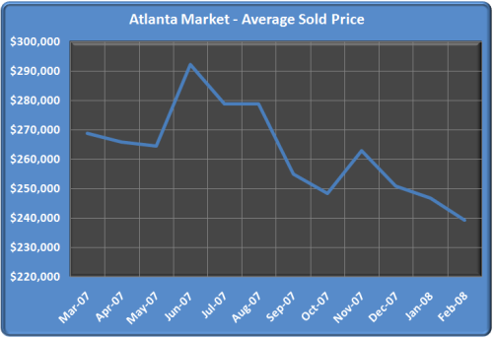

- Sellers are Getting Desperate: The following two charts (from the FMLS) indicate the velocity of real estate transactions in the Atlanta area in recent months. In the first chart, you can see that the number of closed real estate transactions for the end of 2007 is the lowest since the 1990’s. The second chart indicates the number of residential property sales in the Atlanta area compared to the number of homes on the market from June 2007 through January 2008. While the amount of inventory has remained nearly constant, the number of homes sold has dropped dramatically. Sellers who need to sell for one reason or another are being forced to reduce their selling prices to sell their homes:
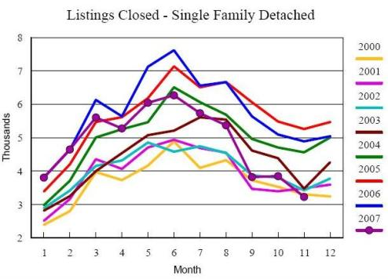
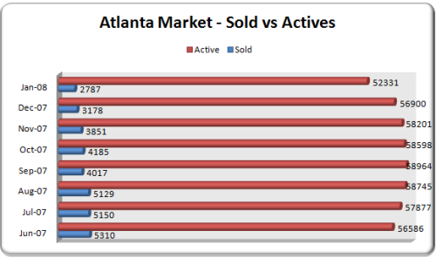

Much like other economic markets, real estate tends to be cyclical, with cycles lasting anywhere from two to ten years. Periods of increased value and transaction velocity are followed by price and market recession, which is then followed again by market appreciation. Atlanta (and much of the country) is currently seeing a pullback in real estate prices and transaction velocity, allowing astute investors the opportunity to buy property at a discount to where we will likely see prices in the next part of the cycle.

Sales & Marketing Strategy
Because selling real estate in today’s market can be a tremendous challenge, the company has done comprehensive research on sales and marketing strategies that will work in the company’s local market. Research has been compiled via local government websites, the local Multiple Listing Service (MLS), and data compiled by a number of real estate brokerage houses throughout the Atlanta metro area.

Sales Strategy
In Cobb County, GA – the company’s target market – there are clear trends that can be identified for local property sales. Houses in specific areas, neighborhoods and subdivisions, as well as houses in specific selling price ranges are seeing relatively high transaction velocity and relatively stable prices.
Specifically, houses in very good condition in the $90,000 - $140,000 price range are continuing to sell quickly in parts of Smyrna, Marietta, Austell, and Mableton, GA. With the $8,000 tax credit being offered by the government for first-time home-buyers, and with the government providing FHA loans to a large segment of qualified buyers, there is an opportunity to target low-end first-time home-buyers in these areas.
As evidence of this existing market, the six previous rehab and resales completed by the company focused on this low-end first-time home-buyer market with tremendous success. Average days-on-market (DOM) for these six properties was under 30 days and average sales price was nearly $125,000. This resulted in an average profit of $27,000 per property for the company.

Marketing Strategy
The company works closely with a full-time real estate and staging consultant who provides all real estate and marketing services to the company. Because of the strong reputation the company has achieved during its first half-dozen rehabs and resales, there continues to be a demand for our properties. This demand has been achieved via a number of marketing strategies implemented by the company and our real estate agent, including:
- Providing the Best Product. When the company undertakes a project, we complete a survey of surrounding homes currently on the market. By walking through these homes with our agent, the company can get a sense of the market competition in the specific neighborhood and the rehab can be targeted at creating a product that is superior to its nearby competition. In addition to producing resale homes that are in better condition than its local competitors, the company aims to product homes that are also lower-priced than competing homes in the area. Because the company is purchasing distressed property at prices far below what local home-owners have paid, we have the ability to sell renovated homes that are both nicer and lower priced than the competition.
- Data Mining. By using the MLS to mine historical sales data, we are able to target those agents who are actively selling homes in the local area and price-range we are selling in. Because buyers are a precious commodity in today’s market, we are going to them (and their agents) instead of waiting for them to come to us. By holding agent-only Open Houses, by providing $500-1000 bonuses to agents who sell our houses, and by offering incentives for repeat business, we are getting many agents to actively pursue our houses for their buyers.
- Marketing Early and Often. In today’s market, the key to selling homes is to generate traffic. This is done by renovating and reselling homes in areas that will receive both foot-traffic from neighbors and drive-by traffic. By placing signs on the property before the rehab begins, we have the ability to generate interest from the outset of the project. By sending marketing letters to all our neighbors inviting them to stop by the renovation, we generate interest by those neighbors who may be current renting, but would love to buy. By holding multiple Open Houses, we are able to get many potential buyers through the door. By the time the rehab is complete, we generally have several leads for potential buyers and are able to get the property under contract within a week or two of listing it for sale.
- Move-In Ready. We ensure that every one of our properties is move-in ready for a first-time home-buyer. This includes providing a brand new full set of appliances with every house (refrigerator, dishwasher, range, microwave), a brand new washer/dryer, and all necessary window treatments, shower curtains and bathroom utilities that are necessary.

Staging
The most effective marketing strategy the company has utilized is home staging. By working with a full time staging consultant and home stager, we are able to separate our houses from the pack by customizing them to our prototypical buyer. Additionally, home staging allows our buyers to visualize what the home will look like fully furnished, providing them an emotional connection the property they’re viewing.
To help reduce the long-term costs of marketing our properties, the company has invested in the purchase of several sets of the staging furniture and accessories for our homes. And, an added marketing benefit to home staging is that many buyers can be incented to purchase a home by agreeing to include some or all of the staging furniture in the price of the home.

Equity & Financing Strategy
The company aims to maintain a balanced investment strategy that uses a reasonable level of built-in equity (i.e., property purchased below market value) and purchased equity (i.e., down-payment) to protect against decreases in property values. At the same time, the company will use the leverage made available through traditional and creative real estate lending vehicles to maximize the asset acquisition and income production of the company overall.

Equity Strategy
In order to maintain a relatively low-risk financial profile across our entire set of properties, it is the goal of the company to maintain at least 20% equity in each property at all times (though some exceptions may be made for short-term sale properties where highly-leveraged bridge loans may be used strategically for short periods of time).
The company will attempt to accomplish this goal of maintaining equity using the following core investing principles around equity management:
- All original financing and refinancing will be made for a maximum of 80% LTV, based on both appraised and bank assumed values of the property (assuming both are available). This will be accomplished by either purchasing a property at below market value (i.e., with built-in equity) and/or ensuring that at least a 20% down-payment is made on the property at acquisition.
- For rehab costs that are provided by a lender, the company will ensure that a maximum of 80% of the rehab costs are financed. By ensuring that at least 20% of the purchase price and 20% of the rehab costs are paid out-of-pocket, the company can be reasonably sure of not over-leveraging and not risking future problems with liquidity or equity.
- For properties being held long-term, it will be the goal of the company to ensure that at least 20% equity is retained in the property at all times. This will be accomplished by ensuring that money will not be taken out of a property until there is at least 30% equity in the property, and that any money taken out of the property at a future time (via refinance, HELOC loan, etc) will still leave at least 20% equity in the property. This should protect the property equity in the case of a market downturn, except in those situations where the downturn immediately follows asset acquisition; even in this case, the company expects that maintaining at least a 20% equity position in every properties will protect against even large negative market trends.

Financing Strategy
Because the company will be purchasing distressed properties, the ability to close quickly will be of utmost benefit to the company. Therefore, the company will do everything possible to ensure that its financing methods provide for a quick and easy closing process.
The company plans to use the following financing methods:
Rehab Loans
The company is working with two local banks that provide “rehab loans” to investors. These rehab loans will satisfy all of the short-term financing needs of the company, and are subject to the following terms:
- Rehab loans will provide financing for both the acquisition and the rehab costs of each project.
- Rehab loans require 20% down-payment on the total loan amount.
- Rehab loans are short-term (12 month) loans, and are interest-only during that 12-month period.
- The interest rate provided is Prime + 1.75%, with a minimum of 6.75%, paid monthly.

Cash Purchases
When the company has accumulated enough cash that is possible to purchase properties without financing, it will do so. Because the typical property purchased and renovated by the company will be less than $100,000, we expect this to be possible starting at some point in year two.

Long-Term Investments
For those properties that are held long-term, it will be necessary to refinance out of the short-term rehab loan or to regain liquidity by pulling out invested cash. In these cases, the company will employ the following refinancing strategy for long-term investments:
- The company will use traditional financing mechanisms to refinance the property, and pull out a portion of the invested cash and/or repay the short-term “rehab loan.”
- In some cases, seasoning requirements may require the company to pursue other short-term financing mechanisms, such as hard money lenders
- Except in special situations, all acquired financing will be in the form of fixed-rate loans with an amortization period of between 15 and 30 years. Situations that might warrant non-fixed rate loans would include: financing intended to cover short-term hold/rehab that will ultimately be refinanced/sold and non-traditional financing necessary to satisfy seller requirements

Investment Strategy

Property Analysis Techniques
When purchasing a property with the goal of turning it around for a short-term sale, the company will take special care to ensure that there is sufficient margin to rehab the property and still sell for a reasonable profit. Too often, properties are purchased for short-term sale with the intent to make a small profit; in many of these cases, if the rehab expenses are under-estimated or the rehab schedule is missed (thereby increasing holding costs), the small profit goes away and can even result in a loss.
The company will ensure that any short-term sales are adequately buffered for rehab overages, schedule slips, and other “surprises,” and that the profit margins are still sufficient based on these buffered estimates. In general, the formula used by the company to analyze a flip is as follows:
Maximum Purchase Price = Sales Price - Fixed Costs - Desired Profit - Rehab Costs, where
Sales Price equals the conservative estimate of what I can sell the property for.
Fixed Costs equal all the costs, fees, and commissions that I can expect to pay during the project.
Desired Profit is the minimum amount of money I want to make off the project when it’s complete.
Rehab Costs are the material and labor costs required to rehab the property into resale condition.

Rehab and Resale Example
Based on our previous experience in this market, here is a realistic example of what a typical acquisition will look like for the company:
The company looks at a bank owned property in Smyrna, GA, listed for sale at $55,000. Based on local comps, the ARV of the property is approximately $120,000 after a full cosmetic rehab. The company makes an initial offer of $40,000, and after multiple rounds of negotiation, a purchase price of $48,000 is agreed upon with the bank. The company estimates the rehab costs be $32,000, including labor and materials.
The company purchases the property using a rehab loan to provide 80% of the total acquisition and rehab price ($64,000) and pays the additional 20% out of the company’s cash reserves ($16,000). Over the next 45 days, the company hires sub-contractors to perform rehab and remodeling work. The total remodeling costs $32,000, as planned, and is paid for from the rehab escrow. Purchase costs ($3000) and holding costs ($2000) total $5000. The finished house has required a total investment of $85,000.
The house is listed for sale at $130,000, and within weeks we receive an offer of $120,000, with the buyer asking us to pay 6% for his closing costs. Between closing costs (6% of $120,000) and realtor commissions (6% of $120,000), the total revenue from the property sale is $105,600.
Total profit after all acquisition, holding, and sales costs is $20,600 for the company. Based on the initial investment of $16,000, that is a 128% ROI on the investment.

Long-Term Hold Example
Let’s say that in the example above, we are not able to resell the property due to a change in market conditions. The backup exit strategy would constitute refinancing into a long-term loan and renting the property for a profit.
Again, here is the likely scenario, given our previous experience in this real estate market:
After rehab of the property above, our total costs are $85,000, and the house will now appraise for $120,000, creating $35,000 in total equity.
Over the following 90 days, the company works with traditional property lenders to refinance the property at 70% of the appraised value ($84,000) at a long-term rate of 7%, ensuring that the resulting loan balance is low enough to allow the property to sufficiently cash flow, and to ensure enough equity remains to mitigate any risk of over-leveraging.
Based on the following realistic assumptions:
- Market Rents: $1100
- Average Vacancy Rate: 8.3% (one month per year)
- Total Expenses: 40% of Net Income

This property should provide the following financial benefits in Year 1:
- Cash flow: $1134
- Equity Accrual: $853 (not including equity generated by rehab)
- Cash-on-Cash Return: 45.01% (not including equity generated by rehab)
- Total Return: 78.87% (not incl. rehab equity or tax benefits, which are investor dependent)

Chart #1: Financial Analysis of Example Property
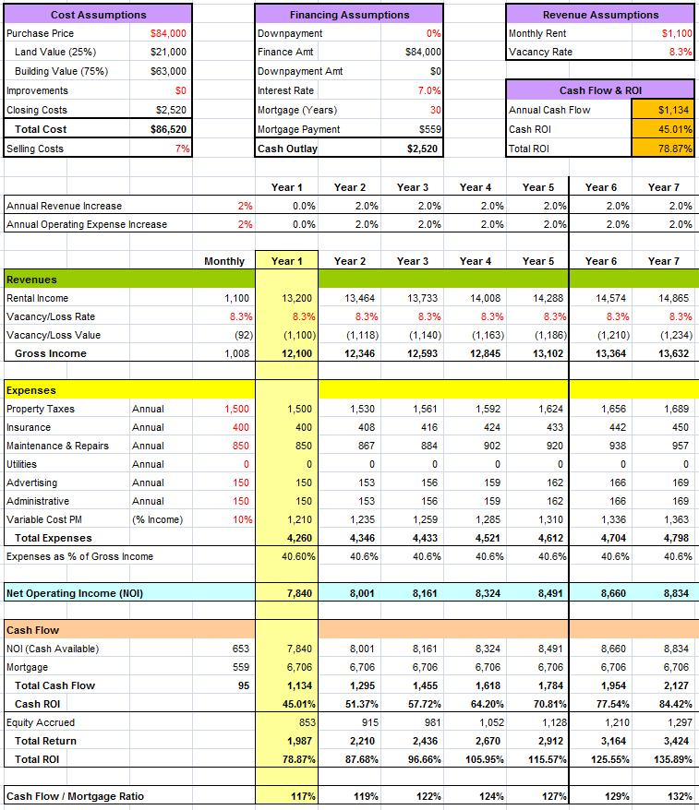

Financial Plan

Initial Investment
The initial capital investment into the company will be $25,000, made by Business Owner. This seed capital will be used to finance the first property, and upon completion of that that first project, should generate enough profit to keep the company on-track to meet its long-term goals.
The acquisition plan use that initial investment and all resulting profits is as follows…

1-Year Acquisition Plan
In the first year, the company expects to acquire, rehab and resell four properties. The first property will be purchased using a combination of the secured rehab loan and the initial investment made to the company. Given the property example above, the company cost to acquire and hold the first property will be approximately $21,000 ($16,000 for the down-payment and $5000 in acquisition and holding costs).
That leaves $4000 to use as cash reserves and a buffer during the first project. Upon completion of the first project, the company should have access to the initial $25,000 in investment, plus about $20,000 in profit from the first project. During the first year, the company will only pursue a single project at a time, thus never requiring additional capital injection.

5-Year Acquisition Plan
Starting in year two, as the company is able to put systems and processes in place to optimize our acquisition and rehab efforts, and as profits provide additional capital, it is expected that additional houses could be purchased each year. Further, the company believes that if it can acquire equity investment through additional partnership with outside investors, it could scale acquisition much more quickly than is laid out above. In this case, the company would likely hire another full-time employee to manage acquisition consulting, project management, and contractor hiring.
The 5-year goal for the company will be to acquire, rehab and resell 40 properties in total, for an overall profit of $1M – $1.2M.
Assuming additional capital injection by other investors, the hiring of additional employees and/or the turn-around of the real estate market, it is possible that these assumptions are highly conservative, and the potential financial upside for the company is much greater.

